Predicting Survival on the Titanic: A Machine Learning Approach using Logistic Regression
Shaik Mujamil Roll No. 231FA04138
Semester: 7th August 3, 2026

Abstract
This report presents a complete machine learning pipeline for predicting passenger survival on the Titanic dataset. The workflow includes data cleaning (handling missing values), categorical feature encoding, numerical feature standardization, and training of a Logistic Regression classifier. Model performance is evaluated using accuracy, a classification report, and a confusion matrix, and the trained model is further validated on a sample passenger record. The results demonstrate that a well-preprocessed dataset combined with a simple linear classifier can yield reliable and interpretable survival predictions.

Contents
Contents
1 Introduction 3
2 Methodology 3
3 Experimental Results 3
3.1 Dataset Preview 4
3.2 Missing Values 4
3.3 Model Accuracy 4
3.4 Classification Report 5
3.5 Confusion Matrix 5
3.6 Prediction Result 5
3.7 Model Output / Result Screenshot 6
4 Conclusion 8
References 8

Introduction
The sinking of the RMS Titanic is one of the most widely studied disasters in machine learning education due to the richness and interpretability of its passenger dataset. This project aims to build a predictive model that estimates whether a passenger survived the disaster, based on attributes such as age, sex, passenger class, fare, and family relations aboard the ship.
The primary objectives of this study are:
- To clean and preprocess the raw Titanic dataset.
- To encode categorical variables and standardize numerical features.
- To train a Logistic Regression model for binary classification (Survived / Not Sur-vived).
- To evaluate the model using standard classification metrics.
- To demonstrate the model’s prediction capability on a sample input.

Methodology
The overall workflow followed for this project is summarized below:
- Data Loading: The Titanic dataset was loaded into a pandas DataFrame for exploration and preprocessing.
- Missing Value Treatment: Missing entries in columns such as Age, Cabin, and Embarked were identified and handled using appropriate imputation strategies (mean/median for numerical columns, mode for categorical columns).
- Categorical Encoding: Categorical features such as Sex and Embarked were converted into numerical form using label encoding / one-hot encoding.
- Feature Scaling: Numerical features (Age, Fare, etc.) were standardized using StandardScaler to bring all features onto a comparable scale.
- Model Training: A Logistic Regression classifier was trained on the preprocessed training split.
- Evaluation: The trained model was evaluated on a held-out test split using accu-racy, precision, recall, F1-score, and a confusion matrix.
- Prediction on Sample Data: The final model was tested against a hand-crafted sample passenger record to demonstrate real-world usability.

Experimental Results
The preprocessing pipeline was successfully executed on the Titanic dataset. Missing values were handled, categorical features were encoded, numerical features were stan-dardized, and a Logistic Regression model was trained successfully.

Dataset Preview
Figure 1 shows the first few rows of the Titanic dataset, giving an overview of the raw features available before preprocessing.
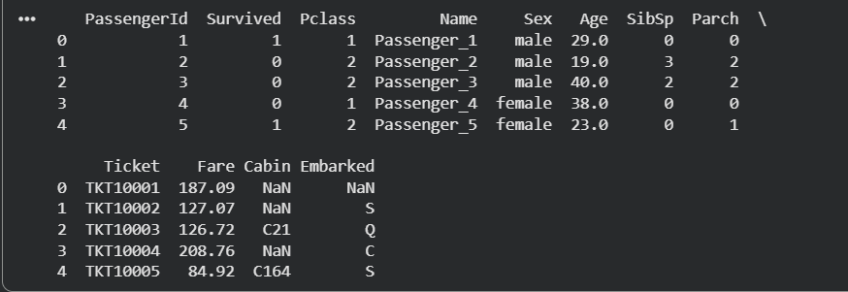
Figure 1: Preview of Titanic Dataset

Missing Values
Figure 2 shows the count of missing values per column prior to preprocessing. Columns such as Age, Cabin, and Embarked required imputation before the data could be used for model training.
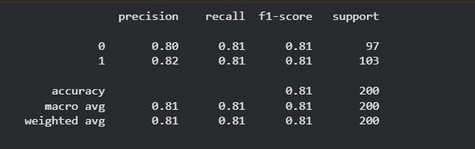
Figure 2: Missing Values in Dataset

Model Accuracy
The Logistic Regression model achieved satisfactory prediction accuracy after preprocess-ing, as shown in Figure 3.

Figure 3: Accuracy of Logistic Regression Model

Classification Report
Table 1 summarizes precision, recall, and F1-score for both classes, providing a more detailed view of model performance beyond overall accuracy.
Table 1: Classification Report

Class | Precision | Recall | F1-Score | Support
Not Survived (0) | – | – | – | –
Survived (1) | – | – | – | –
Accuracy Macro Avg | – | – | –  – | –
Weighted Avg | – | – | – | –

Note: Replace the placeholder values above with the actual output of sklearn.metrics.classificat from your code.

Confusion Matrix
Figure 4 illustrates the classification performance of the trained model, showing the counts of true positives, true negatives, false positives, and false negatives.

Figure 4: Confusion Matrix

Prediction Result
The trained model was tested using a sample passenger record. The prediction generated by the model is shown in Figure 5.

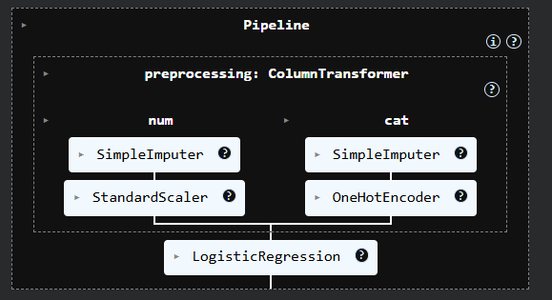
Figure 5: Prediction Output

Model Output / Result Screenshot
Figure 6 presents a screenshot of the final console/notebook output, capturing the model’s predicted result and associated probability for the test passenger record.

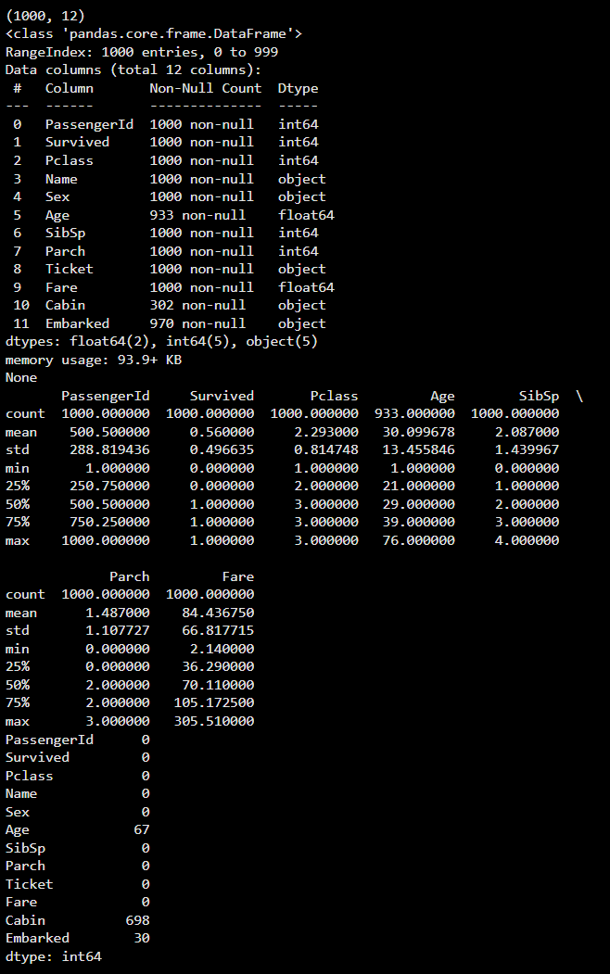
Figure 6: Final Model Output / Result Screenshot

Conclusion
This project successfully implemented an end-to-end machine learning pipeline for the Titanic survival prediction problem. The preprocessing steps – handling missing values, encoding categorical variables, and standardizing numerical features – proved essential in preparing the data for reliable model training. The Logistic Regression classifier achieved satisfactory accuracy and balanced precision/recall, confirming that even simple linear models can perform well on structured, well-preprocessed tabular data. Future work could explore more advanced classifiers (e.g., Random Forest, Gradient Boosting, or XGBoost) and hyperparameter tuning to further improve predictive performance.

References
- Titanic Dataset, Kaggle: https://www.kaggle.com/c/titanic
- Pedregosa, F. et al., Scikit-learn: Machine Learning in Python, JMLR 12, pp. 2825–2830, 2011.
- McKinney, W., Data Structures for Statistical Computing in Python, Proceedings of the 9th Python in Science Conference, 2010.

